# **Sprint 2 User Story Mapping Document**

## **1. Landing Page / Information Page**

**User Story:**

As a user, I would like a landing page that gives me instructions on how to use the website, so that I understand how to use it.

### **User Flow:**

1. The user navigates to the homepage where they are greeted with a brief introduction as well as a navbar with links to different pages

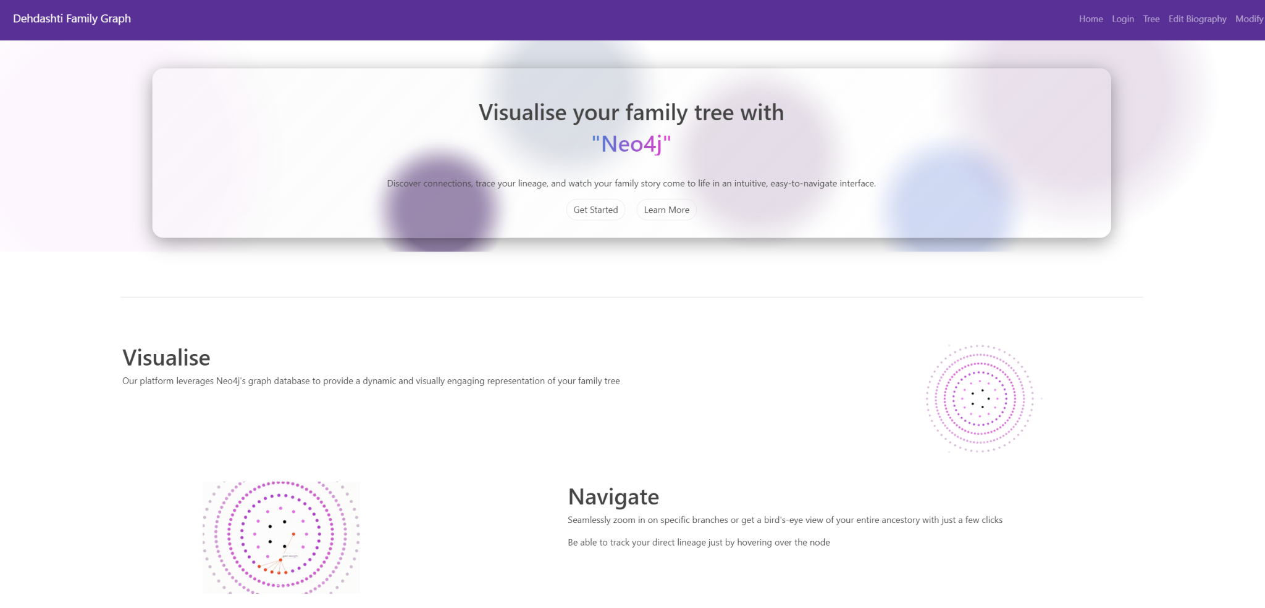

1. The user scrolls down to the “Open User Manual” Button

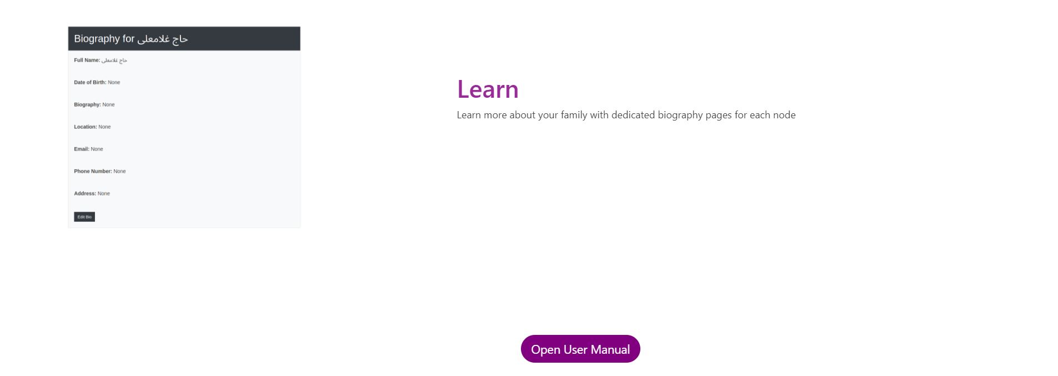

1. A detailed user manual opens on a new tab. This manual can be downloaded locally on the user’s computer

Scroll

## **2. Login/Sign Up Page**

**User Story:**

As a user, I want to have my own account so that I can access family trees that are relevant to me and engage in discussion.

### **User Flow:**

1. The user clicks on the "Login" button.

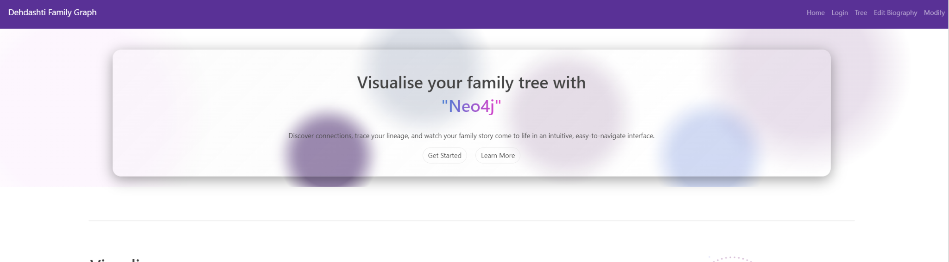

1. The user is taken to the login page

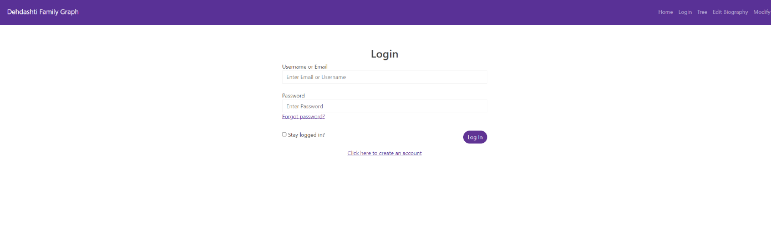

1. If the user is new, they click the “Click here to create an account” link

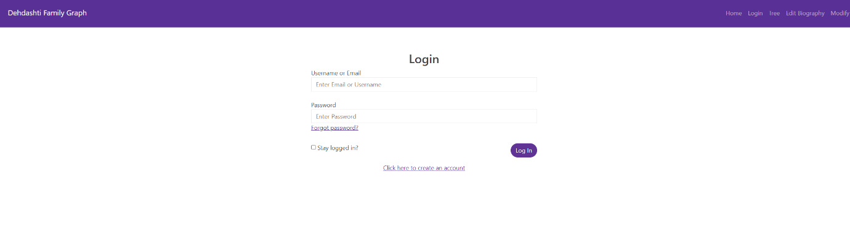

1. The user is directed to the sign-up page

1. The user fills out the sign-up form with personal details and submits it.

1. Upon successful sign-up, the user is redirected to the home page.
2. The user can log in with their newly created credentials by typing their username/email and password in the relevant fields and clicking the “Log in” button.

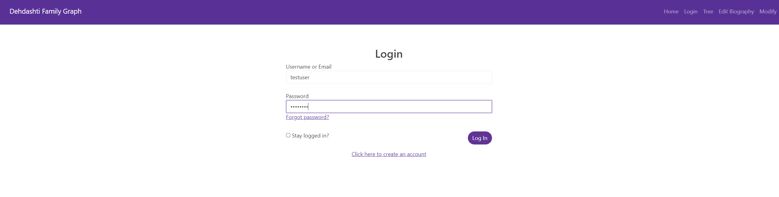

1. After logging in, the user is taken to their personalised dashboard where relevant family trees or discussions are visible.

## **3. Family Tree Page**

**User Story:**

As a user, I want to view a visual representation of my family tree page to understand relationships between members of the tree.

### **User Flow:**

1. The user navigates to the "Tree" section after logging in.



1. A visual representation of the family tree is displayed, showing connected family members.

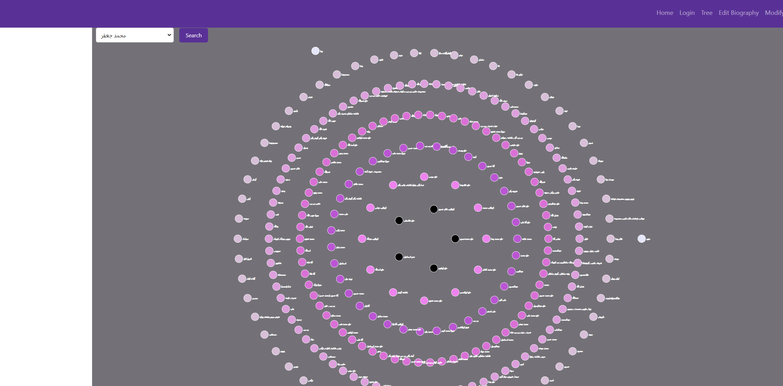

1. The user can interact with the tree by hovering on nodes (family members) to see relations

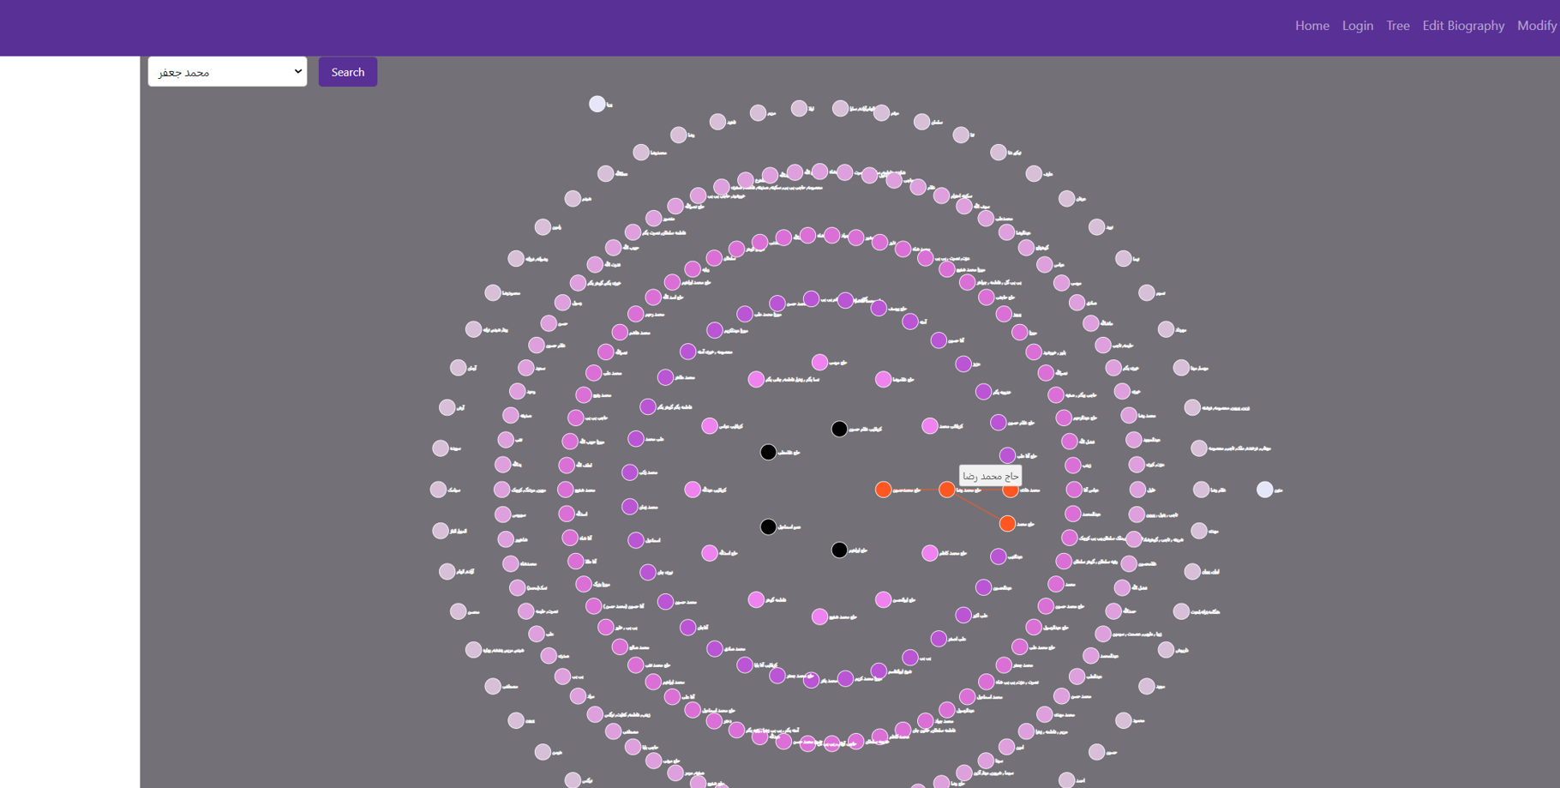

1. The nodes change colour as the user hovers over them. We can see the parent and child relations of the active node. This helps the user explore the relationships between different family members through the visual graph.

## **4. Ability to Create/Update/Delete Nodes**

**User Story:**

As an admin, I want to be able to create, update, and delete nodes in the database so that I can add new information and correct errors in the data.

### **Admin Flow:**

1. The admin logs in and navigates to the “Modify” section.



1. The admin is able to select different actions from the drop-down menu

The admin can :

* Create node using Add Person
* Update node using Edit Person
* Delete node using Delete Person
* Shift node using Shift Person

## **5. Biography Page**

**User Story:**

As a user, I want to be able to see additional information about people in the tree so that I can learn more about specific relatives/ancestors.

### **User Flow:**

1. The user navigates to the family tree page



1. The user double clicks on a specific family member’s node.

1. The system opens a biography page for the selected family member.

1. The biography page contains detailed information such as the family member’s full name, date of birth, email, etc
2. The user reads through the biography to gain more insight into that person’s life.

1. The user could also comment into each biography page

## **6. Add Children to Parents**

**User Story:**

As an admin, I want to be able to easily add new child nodes to parent nodes so that new people can be easily added to existing trees with an automatic relationship between them.

### **Admin Flow:**

1. The admin logs in and accesses the “Modify” section.



1. The admin selects the Add Person option from the dropdown.

1. The admin types the child's Name to be added, selects the Parent name from the dropdown and submits.

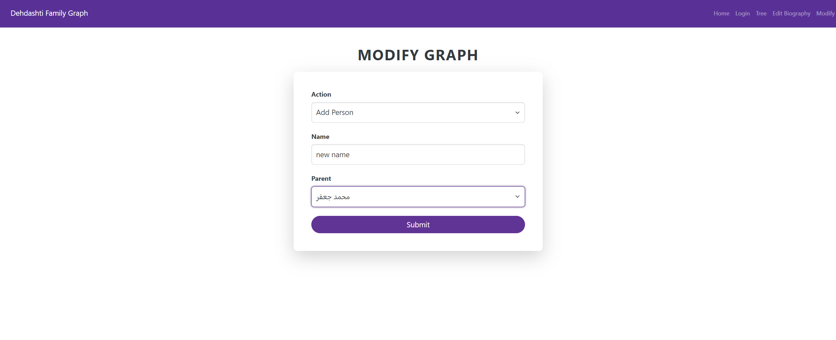

1. The child node is automatically added as a descendant of the parent, and the relationship is created in the tree.